1. Login to github
2. Read Instructions.txt found here --> <https://github.com/MrFiniOrg/Pink/blob/master/INSTRUCTIONS.txt>
3. Open Bash  
   

Run the following cmd…

ls -al ~/.ssh

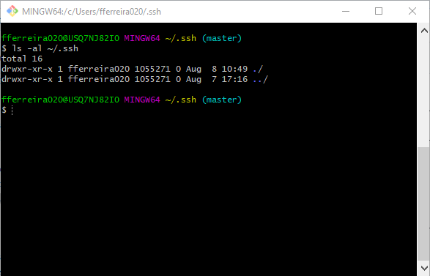

Generating a key…email  
ssh-keygen -t rsa -b 4096 -C 'felipedferreira11@gmail.com'  
enter X 3  
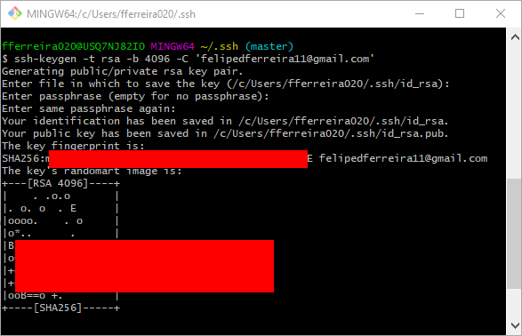

Run the Agent  
eval "$(ssh-agent -s)"



Run the following command…  
ssh-add ~/.ssh/id_rsa

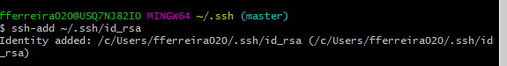

Go to your GitHub accounts Settings

<https://github.com/settings/keys>

Click on New SSH Keys (top right) 

Give it a name and give the RSA.pub key

Getting the RSA_key

Run the following in command prompt to get the RSA value…  
type C:\Users\%UserName%\.ssh\id_rsa.pub | clip && C:\Users\%UserName%\.ssh\id_rsa.pub

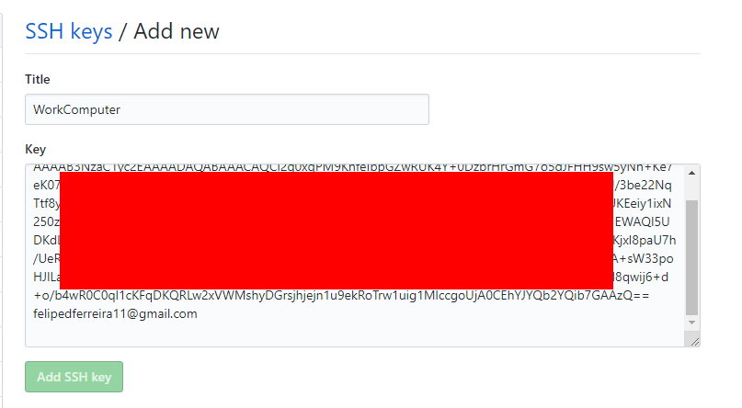

Run the following in Bash and then proceed by typing yes  
ssh -T [git@github.com](mailto:git@github.com)  
then type yes as the screenshot shows

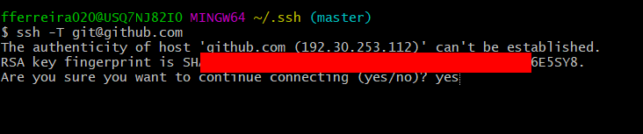

Should give you a confirmation

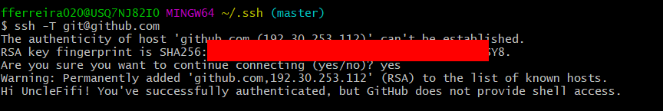

Key should change color…

